**AI-Powered Nutrition Analyser For Fitness Enthusiasts**

1. **INTRODUCTION**
   1. Project Overview

Food is essential for human life and has been the concern of many healthcare conventions. Nowadays new dietary assessment and nutrition analysis tools enable more opportunities to help people understand their daily eating habits, exploring nutrition patterns and maintain a healthy diet. Nutritional analysis is the process of determining the nutritional content of food. It is a vital part of analytical chemistry that provides information about the chemical composition, processing, quality control and contamination of food.

The main aim of the project is to building a model which is used for classifying the fruit depends on the different characteristics like colour, shape, texture etc. Here the user can capture the images of different fruits and then the image will be sent the trained model. The model analyses the image and detect the nutrition based on the fruits like (Sugar, Fibre,

Protein, Calories, etc.).

* 1. Purpose
     + Know fundamental concepts and techniques of Convolutional Neural Network.
     + Gain a broad understanding of image data.
     + Knowhow to pre-process/clean the data using different data pre-processing techniques.
     + Know how to build a web application using the Flask framework.

# 2. LITERATURE SURVEY

## 2.1 Existing Problem

2.1.1 **TITILE : Study for Food Recognition System Using Deep Learning**

### AUHTOR: Nareen O. M. Salim

The evaluation of weight reduction therapy has been shown in the literature to greatly benefit from accurate dietary assessment. The majority of contemporary nutritional evaluation techniques, however, rely on memory. Current computer-based food identification system development for accurate food evaluation is now possible via rich Cloud services and complete mobile devices. Addressing the issue of food detection and identification in images of various foods. The issue is worsened by the wide range of food products with low inter- and large intra-class differences and the scant information in a single image. By outlining the general application of numerous fusion-trained classifiers, it is possible to improve the identification and recognition of traits gleaned from different deep models. This essay investigated numerous methods for identifying foods. The Food identification is a challenging challenge since food products are presented; Sometimes, they are different within the same group. A sort of issue with categorizing fine-grained pictures as the identification of food pairwise local characteristics that take advantage of eight specific food ingredients' positional relationships. The proposed multi-food image recognition system that detects first food recognizes color, texture, gradient, and SIFT extracted by several detectors using multiple kernels learning regions. The food is divided into 300 blocks, and five classes are further classified, such as staple, main dish, side dish, fruit, and non-food from each block's extract color and DCT coefficients. Food identification and quantity estimation are part of the TADA dietary evaluation system.

**2.1.2 TITILE : Efficient extraction of deep image features using convolution neural network (CNN) for applications in detecting and analysing complex food matrices**

### AUHTOR: Yao Liu , Hongbin Pu , Da-Wen Sun b

For the food sector, it is important to establish tools and processes for quickly and accurately identifying and analysing food quality and safety goods. traditional methods for machine learning Based on handcrafted traits, they typically perform poorly since they have a limited capacity to describe complex culinary properties. The convolutional neural network (CNN), which is the most widely used architecture of deep learning and has been increasingly used for the detection and analysis of complex food matrices, has recently emerged as an efficient and viable method for feature extraction. Goals and strategy: The current review introduces multi-feature aggregation techniques, 1-D, 2-D, and 3-D CNN models for feature extraction, and the structure of CNN. CNN's uses as a depth feature. With the improvement of the quality of life, people are increasingly conscious of high quality and safe food products in daily life, therefore the development of methods for reliably detecting and analysing food quality and safety is important for the industry. With the unique advantages of strong feature learning and good generalization ability, CNN is potential and attractive for effective and efficient analysis of complex food matrices. CNN can not only automatically locate important features, but can also obtain unparalleled performance under challenging conditions such as complex background, and different resolutions and orientations of the images. Despite the advantages of CNN in the provision of better performance, there still remain numerous challenges to its applications in the food domain.

**2.1.3 TITILE : The Use of Different Image Recognition Techniques in Food Safety A**

**Study**

### AUHTOR: Rijwan Khan, Santosh Kumar

In order to prevent foodborne illness and harm, food must be properly prepared, transported, and stored. Food products may encounter a variety of health risks from farm to factory and factory to fork. Food safety is therefore essential from a financial and moral standpoint. The consequences of not complying with food safety regulations are diverse.)e demand for precise, rapid, and neutral quality assessments of these qualities in food products is increasing as dietary requirements and high-quality standards are demanded more frequently. To accomplish these goals, computer vision offers an automated, non-destructive, and costeffective method. Its usefulness for fruit and vegetable assessment and classification has been proven by a significant body of research. It highlights the key elements of image processing technology and provides an overview of the most recent developments in the food industry. Public health is consistently and significantly burdened by foodborne illnesses. After more than a century Large-scale changes in food production, distribution, and regulations were pushed and fed into macrosocial pressures like population growth, urbanisation, and globalisation . Compared to other economic sectors, the food industry and distribution network, in particular, have created huge amounts of data in recent years. To increase the safety of the food supply, several types of data were imaginatively examined at various points along the agricultural value chain . For instance, toxic contaminations on farmlands were forecasted in preharvest, field, and weather forecasts; in the retail setting, contactless audits and record-keeping were carried out for 1.4 million months; and observations of Hindawi

Journal of Food Quality Volume

**2.1.4 TITILE : Barriers to and Facilitators for Using Nutrition Apps: Systematic**

### Review and Conceptual Framework AUHTOR: Laura Maria König, Christiane Attig

Diet-related health risk factors and eating habits can both be modified with the help of nutrition apps. Although they might slow the rising rates of overweight and obesity, they haven't yet been widely adopted. Therefore, comprehensive understanding of The development of design recommendations targeted at promoting adoption and sustained use of nutrition apps requires an understanding of the factors encouraging and discouraging (longterm) app use. The literature on obstacles to and enablers of the use of nutrition apps across disciplines, as well as empirical qualitative and quantitative studies with current, former, and non-users of nutrition apps, has been synthesised in this systematic review. PsychINFO, PSYNDEX, PsycArticles, PubMed, Web of Science, and SPORTDiscus were among the six databases used in a comprehensive literature search that also included backward and forward citation searches. The anticipated data extraction procedure, the inclusion and exclusion criteria, and the search strategy were all registered in advance. All empirical qualitative and quantitative publications in German or English that focused on adolescents (aged 13–18) or adults who were either present, former, or non-users of nutrition apps were eligible for inclusion. Individual barriers and facilitators were extracted and put into categories based on a qualitative content analysis. Multiple factors influencing participation with mobile weight reduction and weight maintenance therapies have been discovered by two systematic evaluations. These elements include social support, customisation, ease of use, entertainment, and the availability of tools like self-monitoring, prompts, and feedback.

**2.1.5 TITILE : Identification of malnutrition and prediction of BMI from facial**

### images using real-time image processing and machine learning AUHTOR: Dhanamjayulu C, Nizhal U N

The usable information on human faces can be used to determine an individual's age, gender, weight, etc. Body mass index (BMI) and weight are two of these biometrics that are reliable predictors of health. Based on recent health science studies, this work proposes a regression approach based on the 50-layer Residual network architecture to investigate ways to identify malnourished individuals and obese individuals by evaluating body weight and BMI from facial photos. Multi-task Cascaded Convolutional Neural Networks have been used for face detection. A method is developed to assess BMI, age, and gender using real-time photographs of human faces. Obesity and malnutrition are frequently identified with the aid of BMI. The estimation of height, weight, and BMI using automated methods was done in earlier publications. Today's social networks, like Facebook, Instagram, and Snapchat, contain a variety of functions, including the trading of images, looking for a job, dating, and blogging. More and more people around the world are capturing their lives with digital cameras and publishing the records as images or videos on social media networks. The proposed method is useful in establishing the relation between the characteristics of the human face and the body, such as body height and weight. The proposed method to identify Malnutrition and obese children from human faces. The proposed system does not require the full body real image of a person. Face detection is done with the Multi-task Cascaded Convolution Neural Networks on pictures with single/multiple faces. BMI, age, and gender are estimated from a person’s face using residual neural networks. The problems of BMI, age, and gender estimation are posed as three separate regression pattern classification problems. The dataset of facial images taken from the internet along with their metadata containing information like gender, age, and BMI.

### 2.2REFERENCES

1. Nareen O. M. Salim, Study for Food Recognition System Using Deep Learning,2021
2. Yao Liu , Hongbin Pu, Efficient extraction of deep image features using convolutional neural network (CNN) for applications in detecting and analysing complex food matrices, 2021
3. Rijwan Khan, Santosh Kumar, The Use of Different Image Recognition Techniques in Food Safety: A Study, 2021
4. Laura Maria König, Barriers to and Facilitators for Using Nutrition Apps: Systematic Review and Conceptual Framework, 2021
5. Dhanamjayulu C, Identification of malnutrition and prediction of BMI from facial images using real-time image processing and machine learning, 2021

## 2.3 PROBLEM STATEMENT DEFINITION

Food is a necessity for human life and has been addressed in numerous medical conventions. Modern dietary evaluation and nutrition analysis technologies give consumers more possibilities to explore nutrition patterns, comprehend their daily eating habits, and keep up a balanced diet.

The biggest challenge for fitness lovers is keeping track of their daily nutrition intake, which is crucial for staying in shape. But with today's busy world and the abundance of internet fitness resources, keeping track of your nutrition will become increasingly difficult and inaccurate. Fitness fanatics typically stick to their diet programmers, but they have trouble keeping track of the food's nutritional value.

Fruits are easily digestible since they are high in vitamins, fiber, and minerals, but eating too much of them can cause weight gain and even diabetes because fruit contains natural sugar.

Fitness aficionados eat a diet high in fruits, vegetables, foods high in protein, and low in carbohydrates. However, it is difficult to identify and keep track of the nutritional components of unknown foods, such as fiber, protein, and nutrition.

I am (USER)

User has to upload the food (fruits and vegetables) image to know the healthy content.

I am Trying To

Instead of waiting for a diet expert, users may acquire dietary specifics through this application.

But

This might be the result of a human error, such as a lack of quality control, poor customer service, or even a lack to provide healthy suggestions.

Because

It is hard, and there is a delay to know about the food details and also awkward for providing our healthy facts.

Which makes me feel?

Deep learning algorithms may assist to address these challenges by automating nutrition content assessment. Finally, by analysing the nutritional components in the images, compute the calories, fat, carbs, and protein amounts to give a dietary evaluation report. The addition of more food kinds to the dataset will increase the system's efficiency and precision.

## 3. IDEATION & PROPOSED SOLUTION

### 3.1 Empathy Map Canvas

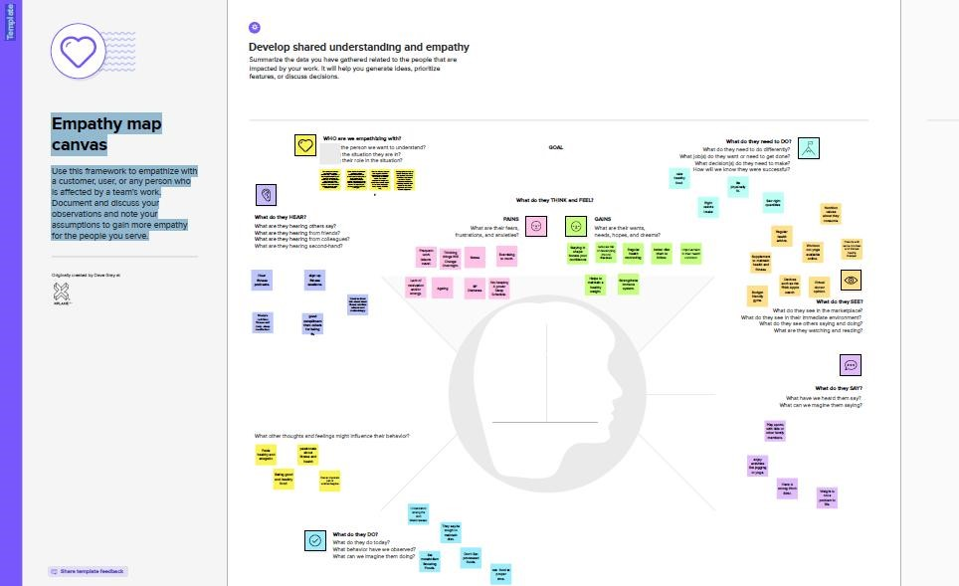

### 3.2 Ideation &Brainstorming

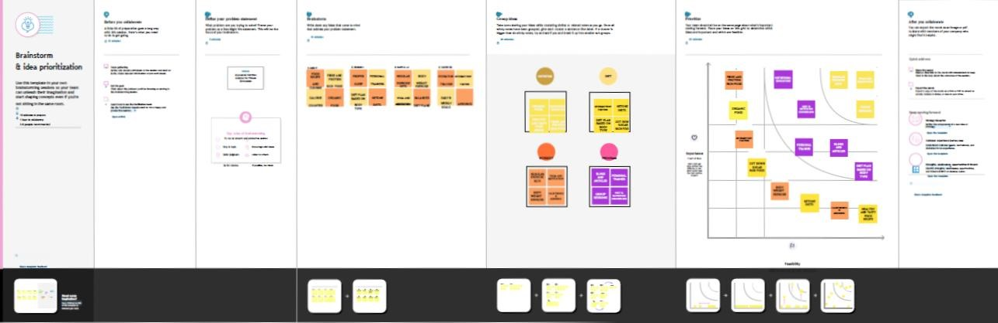

### 3.3 Proposed Solution

To recognise and find food items from the given photographs, develop an automated nutrition analysis system for the proposed system. By locating promising locations and classifying them with deep neural networks, you may create a three-step process only for detecting various cuisines in photographs. From the provided photos, the automatic algorithm initially generates a large number of suggestion regions. Then, it aggregates each region of ideas by placing them on feature maps, categorising them into different food groups, and identifying their locations in the original photos. Finally, by analysing the nutritional elements in the photographs, determine the quantities of calories, fat, carbs, and protein to generate a dietary evaluation report. The system's effectiveness and accuracy will also be increased by expanding the dataset to cover a larger variety of food kinds.

|  |  |  |
| --- | --- | --- |
| **S. No.** | **Parameter** | **Description** |
| 1. | Problem Statement (Problem to be solved) | Due to the uncountable food items as well as the inefficiency of details, usually hard to recognize which food is healthy |
| 2. | Idea / Solution description | Digitalized process might be useful to users and fitness people analyze the nutrition for healthy and diet plan |
| 3. | Novelty / Uniqueness | Provide sustenance such as protein, fat, carbs, vitamin, calories etc., |
| 4. | Social Impact / Customer  Satisfaction | Accurate findings increase people's satisfaction and health. |
| 5. | Business Model (Revenue Model) | - |
| 6. | Scalability of the Solution | Capable of detecting and providing food contents |

### 3.4 Problem Solution Fit

|  |  |  |
| --- | --- | --- |
| **1.CUSTOMER SEGMENTS**  User has to upload the food (fruits and vegetables) image to know the nutrition data | **5. AVAILABLE SOLUTIONS**  Helps to know the facts of food habits and health | **8.CHANNELS OF BEHAVIOUR**  Users should be able to interact with the recommended system and obtain information both online and offline. |
| **2.JOBS TO BE DONE / PROBLEM**  Ineffectual to get the details systematically | **6.CUSTOMER CONSTRAINTS**  Takes more time to get the information | **9.PROBLEM ROOT CAUSE**  There isn't a systematic approach to gather dietary information rapidly. One must wait hours to visit a diet specialist. |
| **3.TRIGGERS**  Help to fitness people to analyze and to know the food calories and  so on | **7.BEHAVIOUR**  The digitalized nutrition assistant makes it simpler for people to obtain information. | **10 YOUR SOLUTION**  Analyze the nutritional elements in the images, and then compute the calories, fat, carbs, and protein levels to give a dietary evaluation report. The system's effectiveness and accuracy will also be increased by expanding the dataset to cover a larger variety of food kinds. |
| **4. EMOTIONS: BEFORE / AFTER**  Before, waiting for a diet expert took a lot of time. After, getting aware of health foods just image. |  |  |

# 4. REQUIREMENT ANALYSIS

**4.1 Functional Requirement**

## Functional Requirements

### Upload Image

In this module, upload the nutrition datasets in the form of CSV file format. In addition, the data is saved in a database for future use. Fruits and vegetables calorie, protein, fat, carbohydrate, vitamin, and cholesterol values are included in the dataset. These values are taken from the Kaggle website and saved as integer values. **Filtering Noise**

Filter techniques are used to remove noise in images in order to evaluate nutrients based on the fruits or vegetables. The filter's objective is to remove noise from photos. It is supported by a statistical methodology. The usual frequency response of a filter is built. Filtering is a nonlinear image processing technique used to minimise "salt and pepper" noise. When edge preservation and noise reduction are concerns, a median filter is superior to convolution.

### Classification

The food image uploaded from the user end will be compared with the food items in the system database for the features obtained in the feature extraction step. The specific food item will be recognised when the perfect match is obtained based on the attributes matched.

The name of the detected food item and the nutrition details will be displayed over the food.

### Nutrition Detection

The request for an insurance claim can be viewed and approved by the insurance company. Once the damaged image has been uploaded and the degree of the damage has been determined, the user may receive insurance only if the firm accepts the damaged image and the condition is greater than 80%.

***Non - Functional Requirements***

## Usability

The system shall allow the users to access the system with pc using web application. The system uses a web application as an interface. The system is user friendly which makes the system easy

## Availability

The system is available 100% for the user and is used 24 hrs a day and 365 days a year. The system shall be operational 24 hours a day and 7 days a week.

## Scalability

Scalability is the measure of a system's ability to increase or decrease in performance and cost in response to changes in application and system processing demands.

## Security

A security requirement is a statement of needed security functionality that ensures one of many different security properties of software is being satisfied.

## Performance

The information is refreshed depending upon whether some updates have occurred or not in the application. The system shall respond to the member in not less than two seconds from the time of the request submittal. The system shall be allowed to take more time when doing large processing jobs. Responses to view information shall take no longer than 5 seconds to appear on the screen.

## Reliability

The system has to be 100% reliable due to the importance of data and the damages that can be caused by incorrect or incomplete data. The system will run 7 days a week. 24 hours a day.

## 5. PROJECT DESIGN

### 5.1 Data Flow Diagram

A Data Flow Diagram (DFD) is a traditional visual representation of the information flows within a system. A neat and clear DFD can depict the right amount of the system requirement graphically. It shows how data enters and leaves the system, what changes the information and where data is stored.

### LEVEL 1

Training

Data

Database

Admin

### LEVEL 2

Testing

Data

Input

Data

Pre-processing

Noise

Filtering

Feature

Extraction

Extract

Shape,

Colour

User

### LEVEL 3

EXTRACTED

MATCHING

WITH

TRAINING

DATA

GIVES

RESULTS

### 5.2 Solution & Technical Architecture

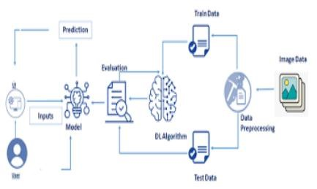

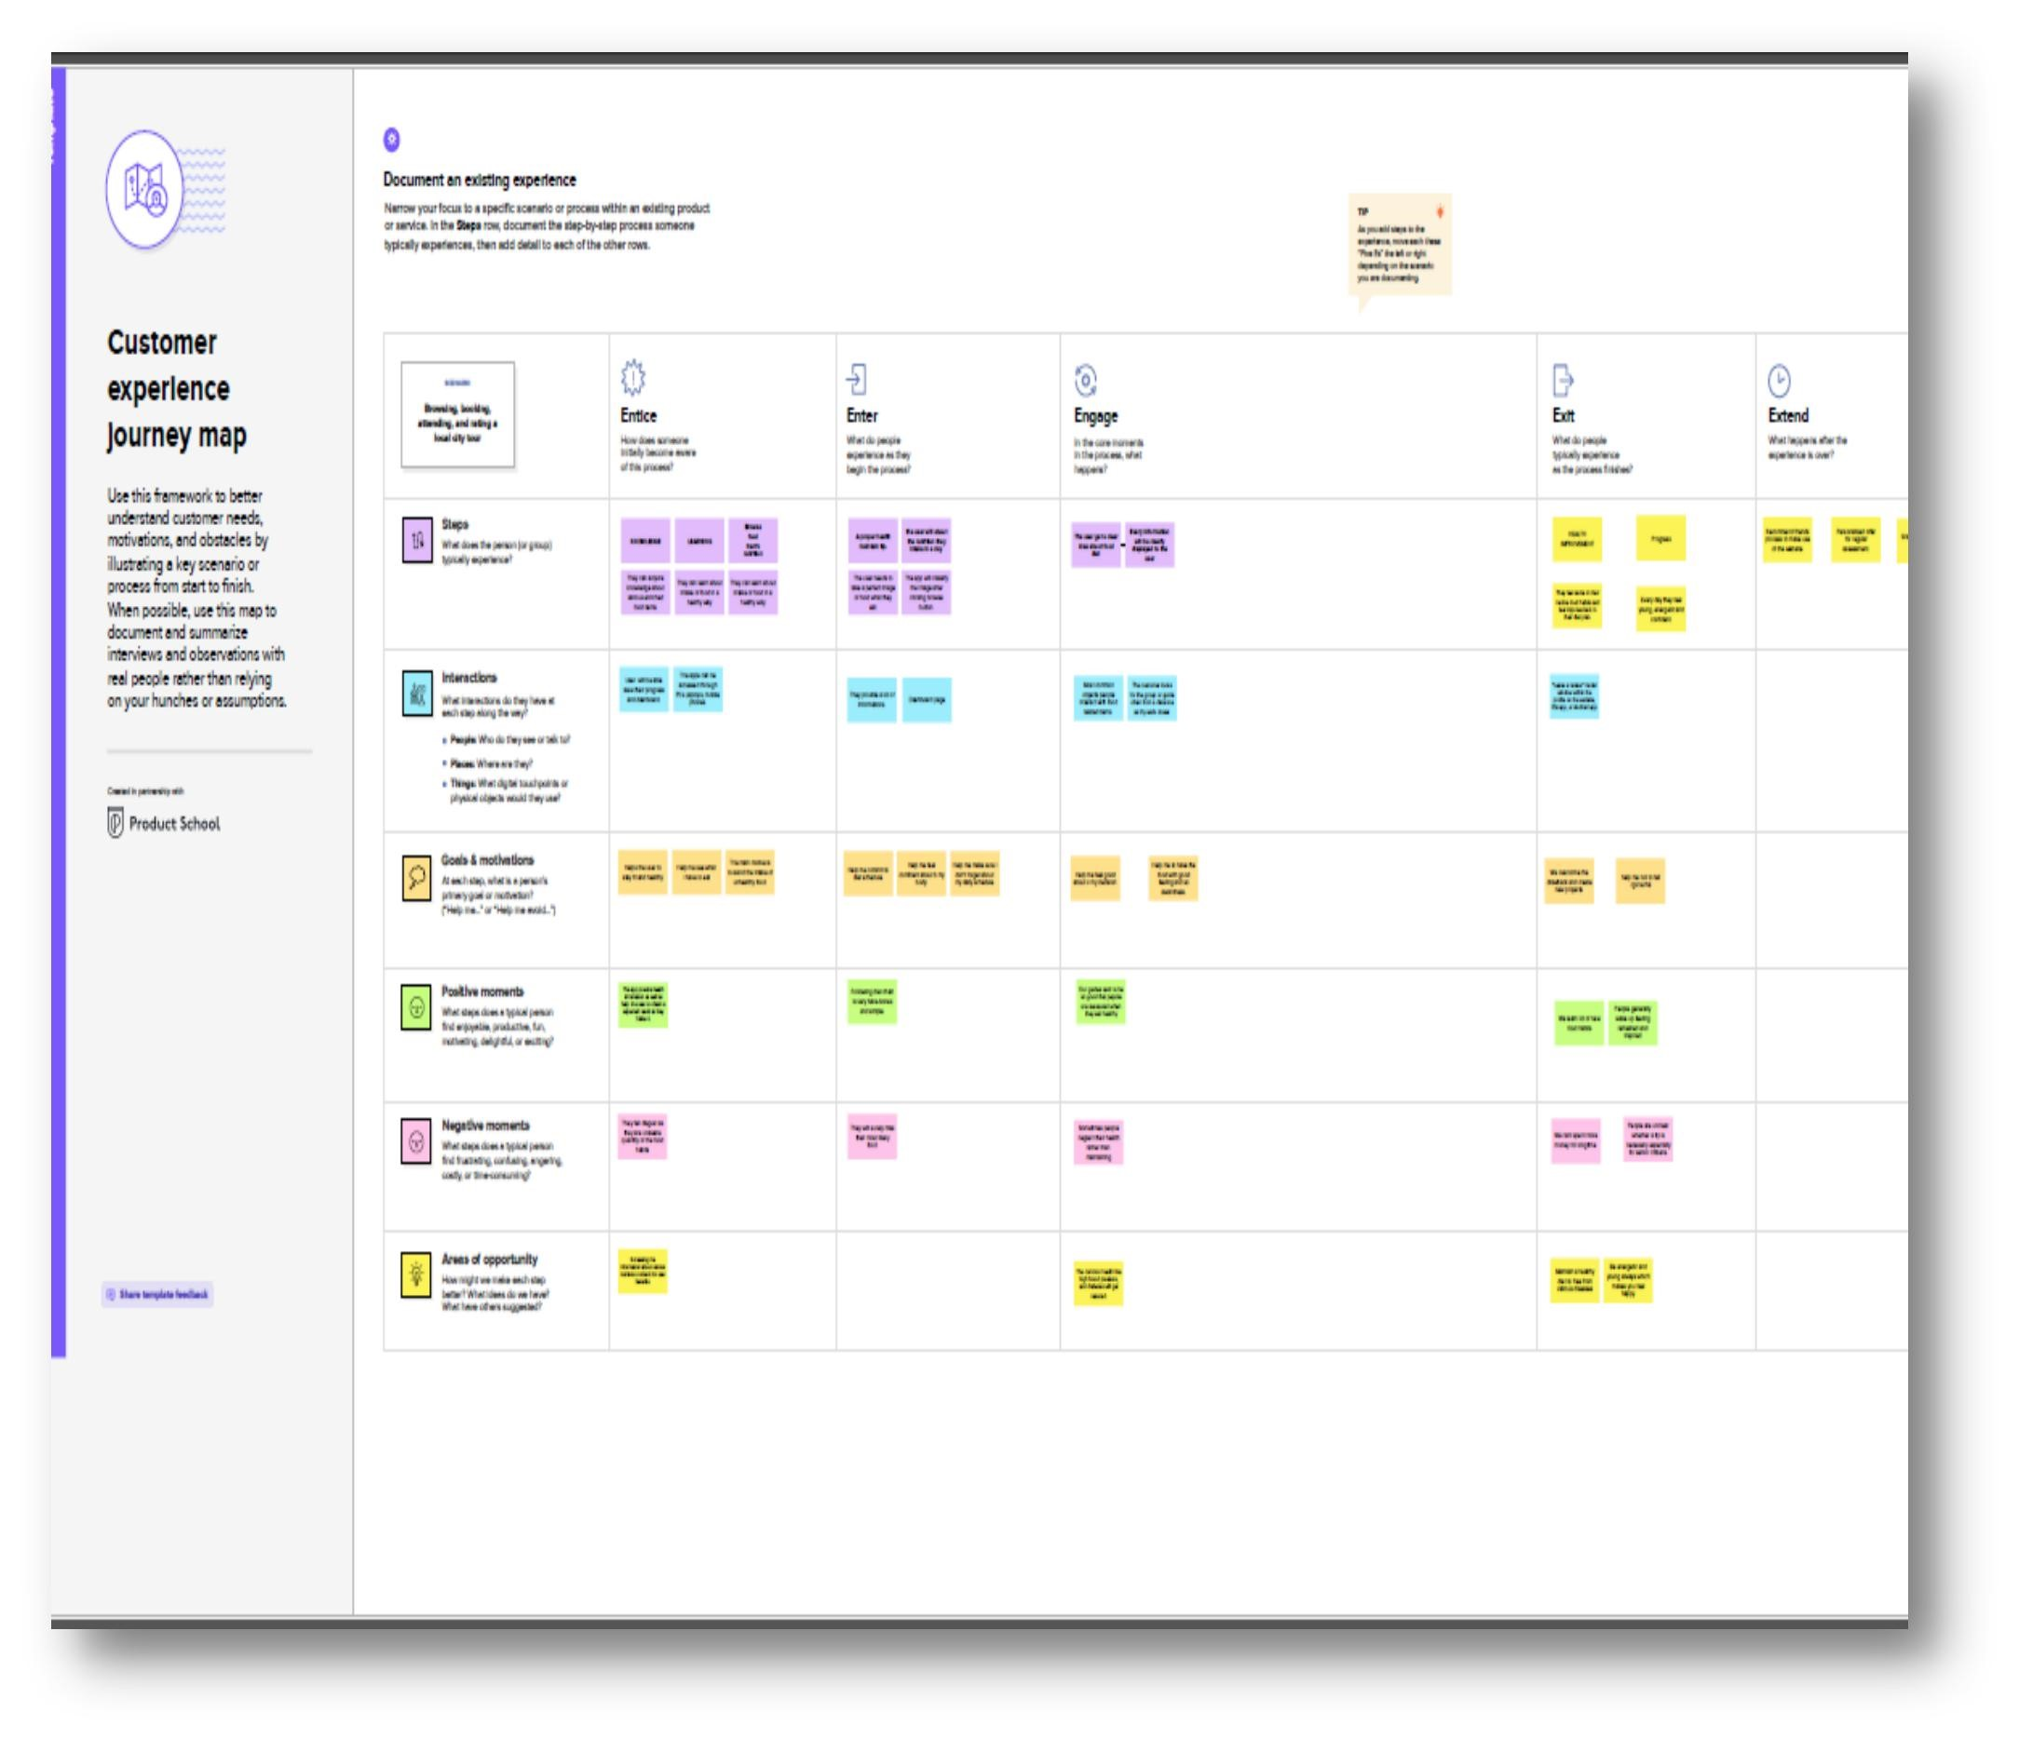**5.3User Stories**

# 6. PROJECT PLANNING & SCHEDULING

## 6.1 Sprint Planning & Estimation

***PRODUCT BACKLOG, SPRINT SCHEDULE, AND ESTIMATION***

|  |  |  |  |  |  |  |
| --- | --- | --- | --- | --- | --- | --- |
| **Sprint** | **Functional**  **Requirement**  **(Epic)** | **User**  **Story**  **Numb**  **er** | **User Story / Task** | **Story Points** | **Priori ty** | **Team Members** |
| Sprint-1 | Data  Collection | USN-1 | Dataset - Collecting images of food itemsapples , banana, orange, pineapple, watermelon for analysis | 5 | High | Aswin,  Abindinesh modak |
| Sprint-1 | Image  Preprocessing | USN-2 | Image data augmentation Increasing theamount of data by generating new data points from existing data | 4 | Mediu  m | Aswin |
| Sprint-1 | USN-3 | Image Data Generator Class Used for  getting the input of the original data | 4 | Mediu  m | Abindineshmod ak,Joe |
| Sprint-1 | USN-4 | Applying image data generator functionality to train set and test set | 4 | Mediu  m | Joe,  Abindines hmodak |
| Sprint-2 | Modeling Phase | USN-5 | Defining the model architecture - Buildingthe model using deep learning  approach and adding CNN  layers | 4 | High | ,  Abindineshmo dak |
| Sprint-2 | USN -6 | Training , saving, testing and  Initializing the model | 5 | High | Aswin  Abindinesh modak |
| Sprint-2 | USN- 7 | Adding Dense layer of model | 4 | High | Aswin |

|  |  |  |  |  |  |  |  |  |  |  |  |  |
| --- | --- | --- | --- | --- | --- | --- | --- | --- | --- | --- | --- | --- |
| **Sprint** | | **Functio nal Requir ement (Epic)** | **User Stor y**  **Num**  **ber** | | **User Story / Task** | | | **Story Points** | | **Priority** | | Team Member  s |
| Sprint2 | | Developme nt phase | USN- 8 | | Project developmentdelivery of sprint1 | | | 3 | | Medium | | Abindin eshmod ak |
| Sprint2 | | Developme nt phase | USN- 9 | | Project developmentdelivery of sprint2 | | | 2 | | Low | | Aswin |
| Sprint2 | | Developme nt phase | USN10 | | Project developmentdelivery of sprint 3 | | | 2 | | Low | | Joe |
| Sprint3 | | Developme nt phase | USN11 | | Project developmentdelivery of sprint4 | | | 2 | | Low | | Aaron |
| Sprint4 | | Model on IBM | USN12 | | Cloud deployment – Deployment of application by using Register for IBM cloud | | | 4 | | High | | Aswin |
| Sprint-4 | | Testing Phase | USN-13 | | Functional testing – Checking usability and accessibility | | | **3** | | Medium | | Aaron |
| Sprint-4 | | Testing Phase | USN-14 | | Non Functional testing – Checking scalability and performance of the application | | | **3** | | Medium | | Joe |
| **Sprint** | **Total**  **Story**  **Points** | | | **Duration** | | **Sprint Start**  **Date** | **Sprint**  **End Date**  **(Planned)** | | **Story Points**  **Completed (as on**  **Planned**  **End Date)** | | **Sprint**  **Release**  **Date**  **(Actual)** | | |
| Sprint1 | 08 | | | 5 Days | | 29 Oct  2022 | 02 Nov 2022 | | 20 | | 3 Nov 2022 | | |
| Sprint2 | 15 | | | 5 Days | | 03 Oct  2022 | 07 Nov 2022 | | 20 | | 8 Nov 2022 | | |
| Sprint3 | 15 | | | 5 Days | | 08  Nov  2022 | 12 Nov 2022 | | 20 | | 11 Nov 2022 | | |
| Sprint4 | 25 | | | 5 Days | | 13  Nov  2022 | 17 Nov 2022 | | 20 | | 16 Nov 2022 | | |

**Velocity:**

Average Velocity= 12/4 =3

## 7. CODING & SOLUTIONING

### 7.1 Features 1

from flask import Flask, render_template, flash, request, session,send_file from flask import render_template, redirect, url_for, request import warnings import datetime import cv2 app = Flask(__name__) app.config['DEBUG'] app.config['SECRET_KEY'] = '7d441f27d441f27567d441f2b6176a'

@app.route("/") def homepage():

return render_template('index.html')

@app.route("/Test") def Test():

return render_template('NewUser.html') @app.route("/testimage", methods=['GET', 'POST']) def testimage(): if request.method == 'POST':

file = request.files['fileupload'] file.save('static/Out/Test.jpg')

img = cv2.imread('static/Out/Test.jpg')

if img is None:

print('no data') img1 = cv2.imread('static/Out/Test.jpg') print(img.shape)

img = cv2.resize(img, ((int)(img.shape[1] / 5), (int)(img.shape[0] / 5))) original = img.copy() neworiginal = img.copy() cv2.imshow('original', img1)

gray = cv2.cvtColor(img1, cv2.COLOR_BGR2GRAY)

img1S = cv2.resize(img1, (960, 540)) cv2.imshow('Original image', img1S) grayS = cv2.resize(gray, (960, 540)) cv2.imshow('Gray image', grayS)

gry = 'static/Out/gry.jpg' cv2.imwrite(gry, grayS)

from PIL import ImageOps,Image im = Image.open(file) im_invert = ImageOps.invert(im)

inv = 'static/Out/inv.jpg' im_invert.save(inv, quality=95) dst = cv2.fastNlMeansDenoisingColored(img1, None, 10, 10, 7, 21) cv2.imshow("Nosie Removal", dst)

noi = 'static/Out/noi.jpg' cv2.imwrite(noi, dst) import warnings

warnings.filterwarnings('ignore')

import tensorflow as tf classifierLoad = tf.keras.models.load_model('model.h5')

import numpy as np

from keras.preprocessing import image

test_image = image.load_img('static/Out/Test.jpg', target_size=(200, 200)) img1 = cv2.imread('static/Out/Test.jpg') # test_image = image.img_to_array(test_image) test_image = np.expand_dims(test_image, axis=0) result = classifierLoad.predict(test_image)

print(result)

out = '' fer = '' if result[0][0] == 1:

out = "APPLES"

fer = '52 calories/1per' \

'Potassium 107mg' \

'Sodium 1mg' \ 'Sugar 10g ' elif result[0][1] == 1:

out = "BANANA"

fer = '100 Calories/1per' elif result[0][2] == 1:

out = "ORANGE"

fer = '50 calories/1per' elif result[0][3] == 1:

out = "PINEAPPLE"

fer = '60 calories/1per' elif result[0][4] == 1:

out = "WATERMELON"

fer = '400 calories/1per ' \

'99% of Water'

org = 'static/Out/Test.jpg' return render_template('NewUser.html',fer=fer,result=out,org=org)

if __name__ == '__main__':

app.run(debug=True, use_reloader=True

7.2 FEATURE 2

# Part 1 - Building the CNN

# Importing the Keras libraries and packages from keras.models import Sequential from keras.layers import Convolution2D from keras.layers import MaxPooling2D from keras.layers import Flatten from keras.layers import Dense from keras.models import model_from_json import matplotlib.pyplot as plt import warnings

warnings.filterwarnings('ignore')

batch_size = 32

from tensorflow.keras.preprocessing.image import ImageDataGenerator

# All images will be rescaled by 1./255 train_datagen = ImageDataGenerator(rescale=1/255)

# Flow training images in batches of 128 using train_datagen generator train_generator = train_datagen.flow_from_directory( 'Data', # This is the source directory for training images target_size=(200, 200), # All images will be resized to 200 x 200

batch_size=batch_size, # Specify the classes explicitly

classes = ['APPLES','BANANA','ORANGE','PINEAPPLE','WATERMELON'], # Since we use categorical_crossentropy loss, we need categorical labels class_mode='categorical')

import tensorflow as tf model = tf.keras.models.Sequential([

# Note the input shape is the desired size of the image 200x 200 with 3 bytes color

# The first convolution tf.keras.layers.Conv2D(16, (3,3), activation='relu', input_shape=(200, 200, 3)), tf.keras.layers.MaxPooling2D(2, 2), # The second convolution

tf.keras.layers.Conv2D(32, (3,3), activation='relu'), tf.keras.layers.MaxPooling2D(2,2), # The third convolution

tf.keras.layers.Conv2D(64, (3,3), activation='relu'), tf.keras.layers.MaxPooling2D(2,2), # The fourth convolution

tf.keras.layers.Conv2D(64, (3,3), activation='relu'), tf.keras.layers.MaxPooling2D(2,2), # The fifth convolution

tf.keras.layers.Conv2D(64, (3,3), activation='relu'), tf.keras.layers.MaxPooling2D(2,2), # Flatten the results to feed into a dense layer

tf.keras.layers.Flatten(),

# 128 neuron in the fully-connected layer

tf.keras.layers.Dense(128, activation='relu'),

# 5 output neurons for 5 classes with the softmax activation

tf.keras.layers.Dense(5, activation='softmax')

])

model.summary() from tensorflow.keras.optimizers import RMSprop early = tf.keras.callbacks.EarlyStopping(monitor='val_loss',patience=5) model.compile(loss='categorical_crossentropy', optimizer=RMSprop(lr=0.001),

metrics=['accuracy']) total_sample=train_generator.n

n_epochs = 10

history = model.fit_generator( train_generator, steps_per_epoch=int(total_sample/batch_size), epochs=n_epochs, verbose=1) model.save('model.h5') acc = history.history['accuracy'] loss = history.history['loss']

epochs = range(1, len(acc) + 1) # Train and validation accuracy

plt.plot(epochs, acc, 'b', label=' accurarcy') plt.title(' accurarcy') plt.legend() plt.figure()

# Train and validation loss

plt.plot(epochs, loss, 'b', label=' loss')

plt.title(' loss')

plt.legend() plt.show()

# 8. TESTING

## 8.1 TEST CASES

A test case has components that describe input, action and an expected response, in order to determine if a feature of an application is working correctly. A test case is a set of instructions on “HOW” to validate a particular test objective/target, which when followed will tell us if the expected behaviour of the system is satisfied or not.

Characteristics of a good test case:

* Accurate: Exacts the purpose.
* Economical: No unnecessary steps or words.
* Traceable: Capable of being traced to requirements.
* Repeatable: Can be used to perform the test over and over.
* Reusable: Can be reused if necessary.

|  |  |  |  |  |
| --- | --- | --- | --- | --- |
| **S.NO** | **Scenario** | **Input** | **Excepted output** | **Actual output** |
| 1 | User login | User name and  password | Login | Login success. |
| 2 | Upload Image | Upload input image (fruits and vegetables) | Predicting calorie, fat, carbs and food content of given image | Details are stored in a database. |

## 8.2 USER ACCEPTANCE TESTING

This sort of testing is carried out by users, clients, or other authorised bodies to identify the requirements and operational procedures of an application or piece of software. The most crucial stage of testing is acceptance testing since it determines whether or not the customer will accept the application or programme. It could entail the application's U.I., performance, usability, and usefulness. It is also referred to as end-user testing, operational acceptance testing, and user acceptance testing (UAT).

# 9. RESULTS

## 9.1 PERFORMANCE METRICS

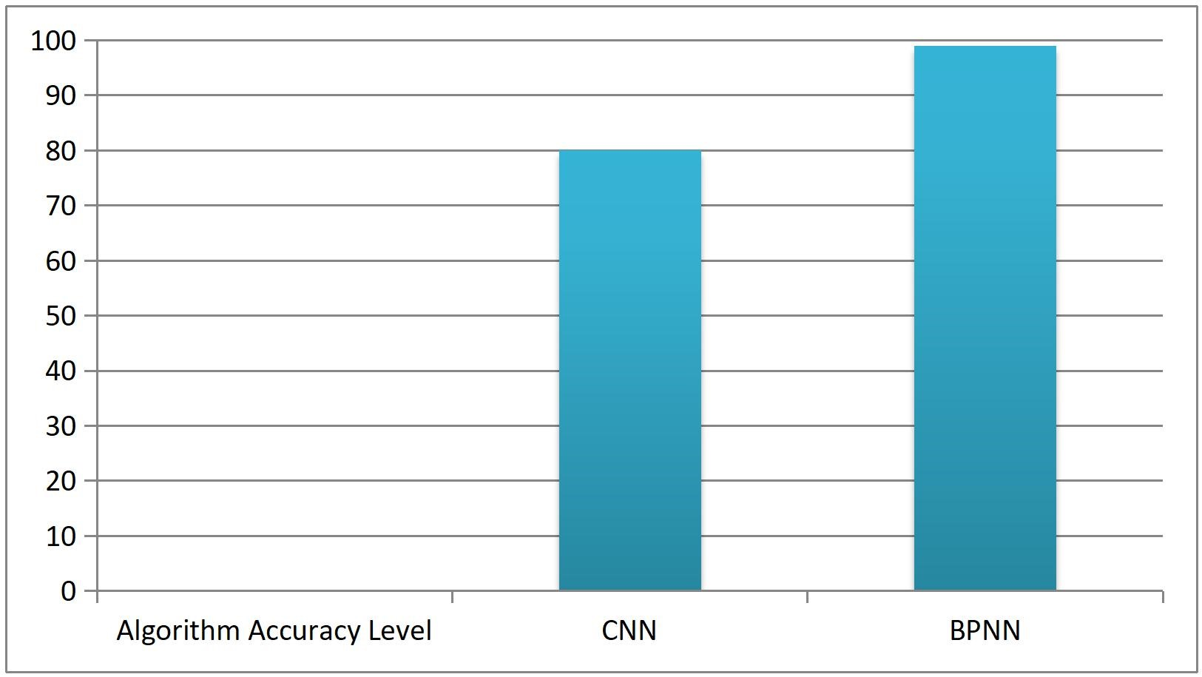

# 10. ADVANTAGES & DISADVANTAGES

**ADVANTAGE**

* Provide the nutrition content of Multifoods
* Helps for fitness people to maintain and know the proteins and calories of the food
* Gives accurate results in real-time application

## DISADVANTAGE

* Hard to know the details of nutrition and calories of food
* Doesn’t ask to provide the users health condition
* Required more time to know the Multifoods

# 11. CONCLUSION

The approach for an automated food nutrition detection system that can determine the amount of nutrients in food is proposed in this project work. The machine has so far been able to place the meal into one of the many categories listed in the dataset. The well-known food dataset was used for the categorization. The classification of the food photos into their appropriate classifications using a deep learning approach. By reducing noise from the dataset, the classification process may be made better. The same research may be done with a larger dataset, more classes, and more photos in each class since a larger dataset increases accuracy by teaching the algorithm additional features and lowers the loss rate. The model's weights may be saved and used to create designs for food categorization, calorie extraction, and picture classification.

# 12. FUTURE SCOPE

The food photographs in this research study are categorised into the appropriate groups using a deep learning approach. In terms of future improvement, the classification task may be made better by reducing noise from the dataset. The same research may be done with a larger dataset, more classes, and more photos in each class since a larger dataset increases accuracy by teaching the algorithm additional features and lowers the loss rate. The model's weights may be saved and utilised to create a web or mobile application that classifies images and also extracts the calories from the food that has been identified.

**1. APPENDIX**

## SOURCE CODE

from flask import Flask, render_template, flash, request, session,send_file from flask import render_template, redirect, url_for, request import warnings import datetime import cv2 app = Flask(__name__) app.config['DEBUG'] app.config['SECRET_KEY'] = '7d441f27d441f27567d441f2b6176a'

@app.route("/") def homepage():

return render_template('index.html')

@app.route("/Test") def Test():

return render_template('NewUser.html') @app.route("/testimage", methods=['GET', 'POST']) def testimage(): if request.method == 'POST':

file = request.files['fileupload'] file.save('static/Out/Test.jpg')

img = cv2.imread('static/Out/Test.jpg') if img is None:

print('no data')

img1 = cv2.imread('static/Out/Test.jpg') print(img.shape)

img = cv2.resize(img, ((int)(img.shape[1] / 5), (int)(img.shape[0] / 5))) original = img.copy() neworiginal = img.copy() cv2.imshow('original', img1) gray = cv2.cvtColor(img1, cv2.COLOR_BGR2GRAY) img1S = cv2.resize(img1, (960, 540)) cv2.imshow('Original image', img1S) grayS = cv2.resize(gray, (960, 540)) cv2.imshow('Gray image', grayS) gry = 'static/Out/gry.jpg' cv2.imwrite(gry, grayS) from PIL import ImageOps,Image im = Image.open(file) im_invert = ImageOps.invert(im) inv = 'static/Out/inv.jpg' im_invert.save(inv, quality=95) dst = cv2.fastNlMeansDenoisingColored(img1, None, 10, 10, 7, 21) cv2.imshow("Nosie Removal", dst) noi = 'static/Out/noi.jpg' cv2.imwrite(noi, dst) import warnings warnings.filterwarnings('ignore') import tensorflow as tf classifierLoad = tf.keras.models.load_model('model.h5') import numpy as np from keras.preprocessing import image test_image = image.load_img('static/Out/Test.jpg', target_size=(200, 200)) img1 = cv2.imread('static/Out/Test.jpg') # test_image = image.img_to_array(test_image) test_image = np.expand_dims(test_image, axis=0) result = classifierLoad.predict(test_image) print(result) out = '' fer = ''

if result[0][0] == 1: out = "APPLES"

fer = '52 calories/1per' elif result[0][1] == 1:

out = "BANANA"

fer = '100 calories/1per' elif result[0][2] == 1:

out = "ORANGE"

fer = '50 calories/1per' elif result[0][3] == 1: out = "PINEAPPLE"

fer = '60 calories/1per' elif result[0][4] == 1:

out = "WATERMELON"

fer = '400 calories/1per' org = 'static/Out/Test.jpg' return render_template('NewUser.html',fer=fer,result=out,org=org) if __name__ == '__main__':

app.run(debug=True, use_reloader=True)

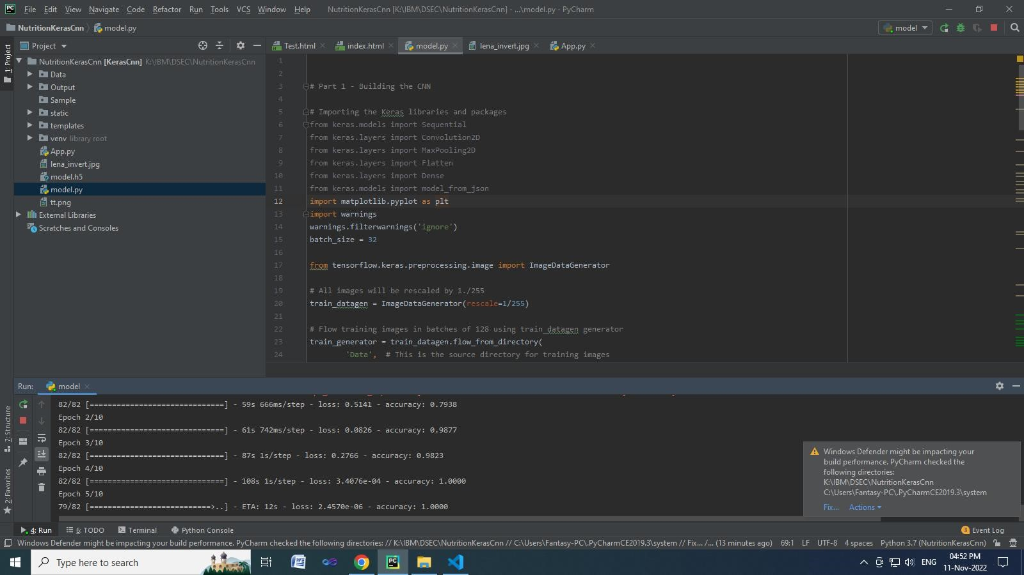

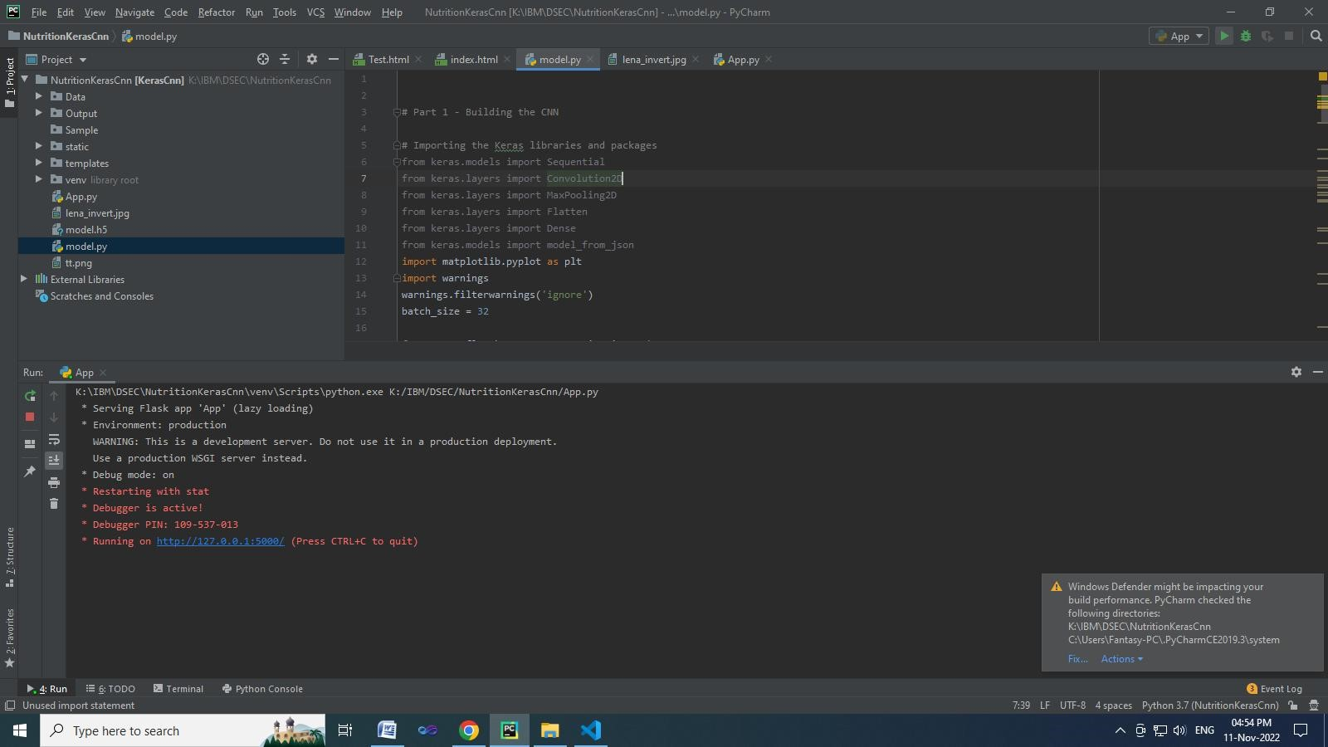

# HOMEPAGE

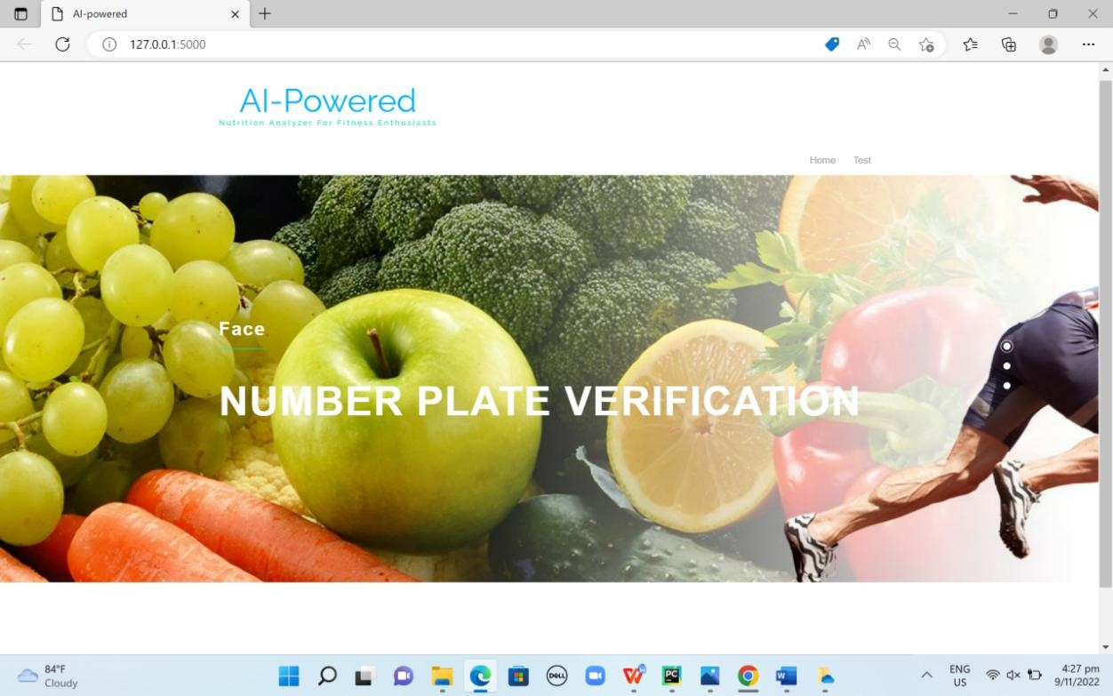

## TEST PAGE

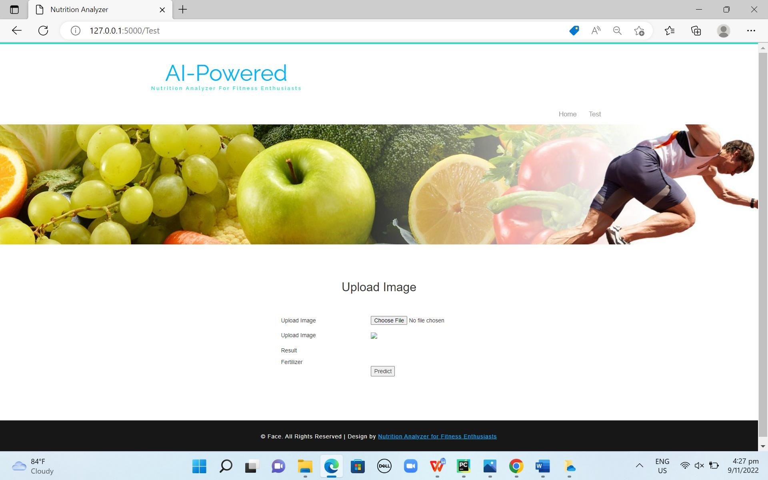

## PREDICT PAGE

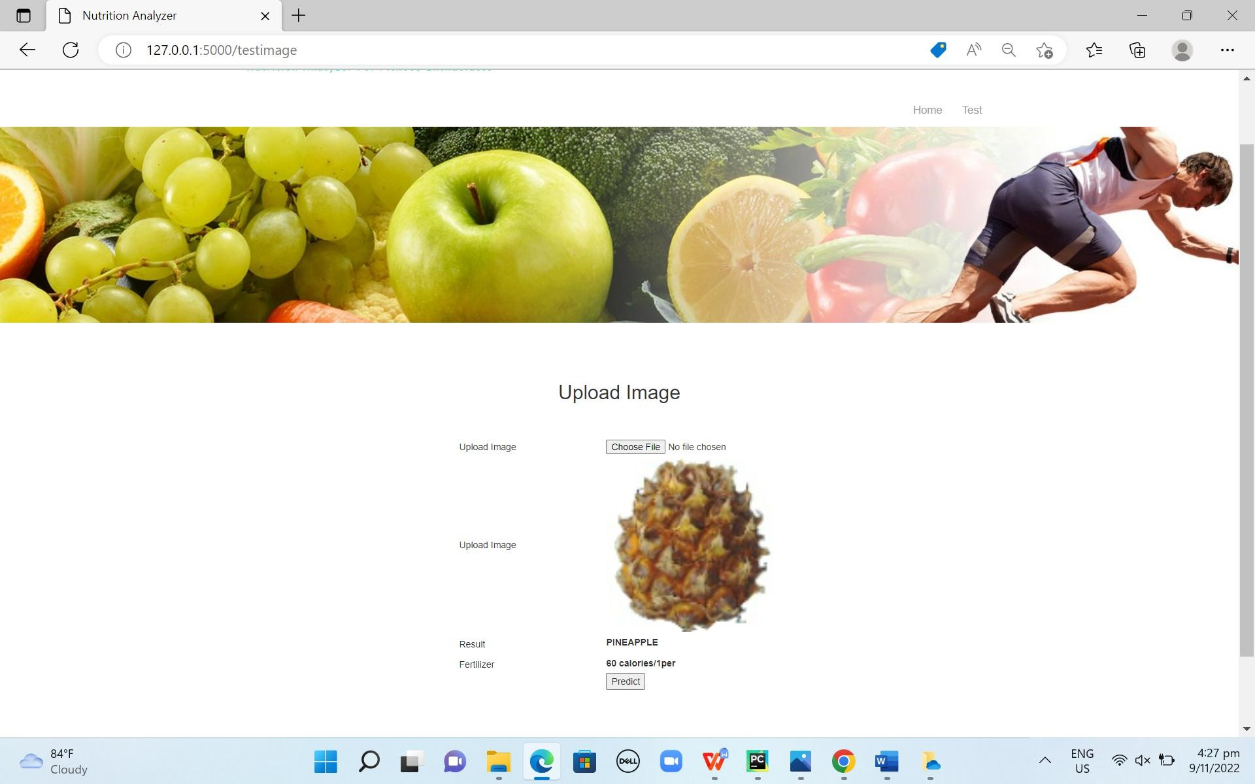

### GITHUB & PROJECT DEMO LINK

**Youtube Demo Link:** [**https://youtu.be/b5pAjZVWdhg**](https://youtu.be/b5pAjZVWdhg)

**GITHUB :** [**https://github.com/IBM-EPBL/IBM-Project-14133-1659542451**](https://github.com/IBM-EPBL/IBM-Project-14133-1659542451)